**5th-Grade Art Lesson 6/01/2020 NFCSD Art Educators**



**Sketching like Leonardo da Vinci**

Supplies: Paper and any of these: pencils, crayons, colored pencils, pen or markers.

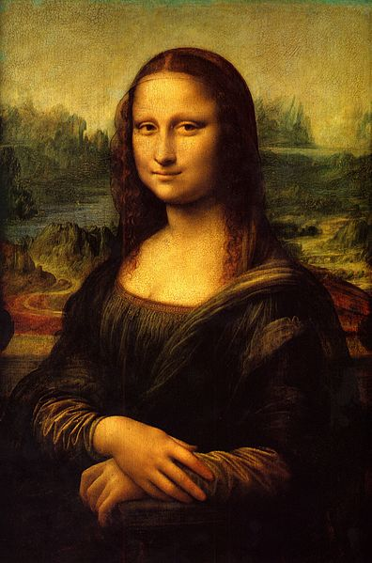**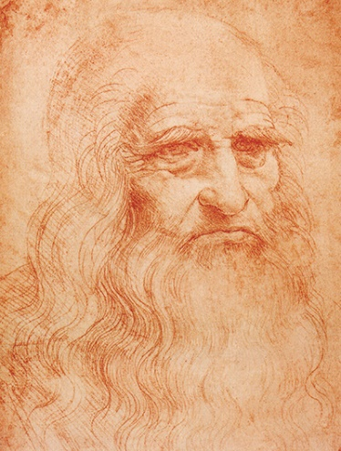Leonardo da Vinci** was born on April 15, 1452 in the village of Vinci in Italy. He began painting world famous **Mona Lisa** in 1503. How many years ago was that?

Leonardo drew this **self-portrait** on the left with red chalk on paper. Historians believe it was drawn in the year 1512. Can you figure out how old he was then?

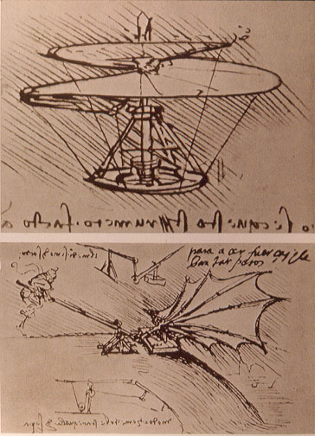Leonardo was much more than a gifted artist. He was a scientist and inventor. From his **imagination**, he made sketches of helicopters, airplanes and other machines not even invented when he was alive. From **observation**, da Vinci made detailed drawings of plants and animals. He filled over 100 notebooks with drawings and ideas. He wrote backwards, from right-to-left, so his notes could only be read in a mirror.

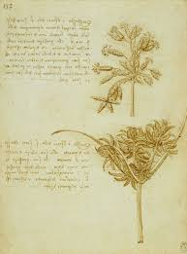

Leonardo lived to be 67 years old. In what year did he die?

**\*Observation!** Find some interesting objects in your house or yard. Look at them slowly and carefully to notice every detail. Sketch what you see. Write notes too.

**\*Share your drawings.** Did you notice anything unexpected while looking carefully? Did you try writing backwards and reading it in the mirror? Share your thoughts about Leonardo da Vinci?